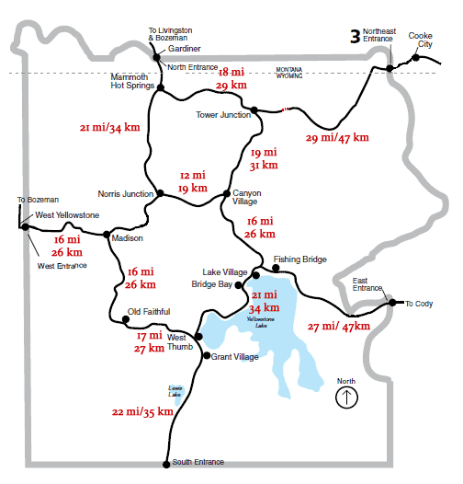

**Yellowstone National Park**

**Meet**

**Here!**

MEET

HERE

**MEET**

**HERE**